Life Cycle Plan (LCP)

Mission Science Information and Database System

Team 06

Brian Anderson – Operational Concept Engineer
Kathleen Barrera – IIV&V
Yujie Chen – Prototyper
Celia Kung – Project Manager
Hardik Shah – Feasibility Analyst
Zhenlu Sun – Requirements Engineer
Wei Tan – System Architect

Version History
Date | Author | Version | Changes made | Rationale
09/26/11 | CK | 1.0 | - Updated section 3.3 with team members’ skills | - Initial draft for VC package
10/07/11 | CK | 1.1 | - Made changes to section 3.3 to reflect team members’ skills rather than team members’ tasks and responsibilities  - Updated section 1  - Started to update section 2.1 | - Minimum exit requirements for core FC package
10/13/11 | CK | 1.2 | - Included sections 2, 3.1, 3.2, 4 | - To complete document for the draft FC package
10/17/11 | CK | 1.3 | - Performed cost estimation using COCOMOII tool and appended results to “Resources” section | - To complete document for DC package
10/19/11 | CK | 1.4 | - Modified Section 3 Responsibilities  - Performed cost estimation using COTIPMO and replaced COCOMO estimations in “Resources” section | - To reflect the addition of a new team member and responsibilities/roles for development phase  - NDI projects should use COTIPMO
11/19/11 | CK | 1.5 | - Updated Section 1.2 Status of the LCP  - Modified Section 3.2 Responsibilities by Phase  - Updated Cost Estimation screen shots in “Resources” section | - To reflect current status of LCP  - To specify specific responsibilities in Transition phases  - To complete document for Draft Transition Readiness Review (TRR) Package
12/05/11 | CK | 1.6 | - Updated Cost Estimation screen shots in “Resources” section | - To complete document for Final Transition Readiness Review (TRR) Package

Table of Contents
Life Cycle Plan (LCP) i
Version History ii
Table of Contents iii
Table of Tables iv
Table of Figures v
1. Introduction 1
1.1 Purpose of the LCP 1
1.2 Status of the LCP 1
1.3 Assumptions 1
2. Milestones and Products 2
2.1 Overall Strategy 2
2.2 Project Deliverables 3
3. Responsibilities 8
3.1 Project-specific stakeholder’s responsibilities 8
3.2 Responsibilities by Phase 8
3.3 Skills 12
4. Approach 14
4.1 Monitoring and Control 14
4.2 Methods, Tools and Facilities 14
Resources 15

Table of Tables
Table 1: Artifacts Deliverables in Exploration Phase 3
Table 2: Artifact Deliverables in Valuation Phase 3
Table 3: Artifact Deliverables in Foundations Phase 5
Table 4: Artifact Deliverables in Development Phase 6
Table 5: Stakeholder's Responsibilities in each phase 8
Table 6: Skills of Team Members by Role 12
Table 7: Methods, Tools, and Facilities Used in Project 14

Table of Figures
Figure 1: Project estimation for Mission Science Information and Database System 15
Figure 2: Cost estimation for Iteration 1 16
Figure 3: Project Progress Chart 16

    - Introduction

Purpose of the LCP
The purpose of this Life Cycle Plan document is to describe the details of the Mission Science Information and Database System project in its entirety. This document will serve to answer questions related to the motivation for this project, the stakeholders involved, the time frame and longevity of the project and its benefits, and total cost to complete this project.

Status of the LCP
The status of the LCP is currently at the Transition Readiness Review Package, version number 1.6. This is the version that serves as a reference for the developers on the team, for now. The major changes from the LCP of the Development Commitment Package are:
  - The COTIPMO estimate screen shots are up to date and include all 7 iterations

Assumptions
  - The duration of the project is 12 weeks and can be completed in the Fall 2011 semester, which ends in December 2011, as this project is NDI-intensive and does not require major architecture design.
  - The client will remove all duplicates from the existing student information database, so that the development team will not have to build a program that does this.
  - The client will present the team with complete data in a specified input format so that the team can receive data in that format and store it into the new database system; this will save time with the data migration requirement.
  - The database system can remain in Microsoft Access, and no major user interface changes or developments are necessary, as long as the MS Access interface is user-friendly
  - The database system does not have to be accessible over the internet from different school sites

    - Milestones and Products

Overall Strategy
The Mission Science Information and Database System project is following a Single-NDI process because the requirements of this project only include database design and organization and data migration. There already exists a single Non-Developmental Item, Microsoft Access, which can fit most of the core functionalities desired.

Exploration phase
Duration: 09/09/2011- 10/07/2011
Concept: To assess who the success-critical stakeholders are, determine system capabilities, analyze the current system infrastructure, identify the operational concept, perform benefit analysis, assess the abilities of team software developers, identify any possible risks associated with the project, and plan the life cycle of the project.
Deliverables: Valuation Commitment Package – OCD, FED, LCP; Client Interaction Report
Milestone: Valuation Commitment Review
Strategy: One Incremental Commitment Cycle

Valuation phase
Duration: 10/07/11- 10/14/11
Concept: To identify the objectives, constraints, and priorities of the project based on negotiation of Win conditions amongst success-critical stakeholders, to explore NDI alternatives, reassess and plan the project life cycle, create a prototype of the system and its capabilities, and acquire and familiarize with NDI components.
Deliverables: Core Foundations Commitment Package – OCD, PRO, WWCP, SSAD, LCP, FED, SID
Milestone: Core Foundations Commitment Review
Strategy: One Incremental Commitment Cycle

Foundations phase
Duration: 10/14/11- 10/24/11
Concept: To detail the project plan, to assess and record project and individual progress, to assess feasibility, operational concept, system architecture, prototype, and life cycle, to prioritize capabilities included in prototype, and to acquire NDI components.
Deliverables: Development Commitment Package – OCD, PRO, SSRD, SSAD, LCP, FED, SID, QMP, ATPC, IP
Milestone: Development Commitment Review
Strategy: One Incremental Commitment Cycle

Development phase
Duration: 10/24/11- 12/05/11
Concept: To assess the development iteration, implement the system, perform testing, develop a support plan and transition plan, and continue to perform testing
Deliverables: Transition Readiness Review Package (TRR) – OCD, PRO, SSAD, LCP, FED, SID, QMP, IP, ATPC, IAR, TP, UM, TM, ATPR
Milestone: Re-Baselined Development Commitment Review
Strategy: One Incremental Commitment Cycle

Project Deliverables

Exploration Phase
Table 1: Artifacts Deliverables in Exploration Phase
Artifact | Due date | Format | Medium
Client Interaction Report | 09/21/2011 | .doc, .pdf | Soft copy
Valuation Commitment Package  - Operational Concept Description (OCD) Early Section  - Life Cycle Plan (LCP) Early Section  - Feasibility Evidence Description (FED) Early Section | 09/28/2011 | .doc, .pdf | Soft copy
Evaluation of Valuation Commitment Package | 10/03/2011 | .xls | Soft copy
Project Effort | Every Monday | Text | ER system
Project Plan | Every Wednesday | .mpp | Soft copy
Progress Report | Every Wednesday | .xls | Soft copy

Valuation Phase
Table 2: Artifact Deliverables in Valuation Phase
Artifact | Due date | Format | Medium
Core Foundations Commitment Package  - Operational Concept Description (OCD) All Sections  - Prototype (PRO) Some Sections  - WinWin Conditions Prioritization (WWCP)  - System and Software Architecture Description (SSAD) Some Sections  - Life Cycle Plan (LCP) Some Sections  - Feasibility Evidence Description (FED) Some Sections  - Supporting Information Document (SID) All Sections | 10/07/2011 | .doc, .pdf, .xls | Soft copy
Evaluation of Core Foundations Commitment Package | 10/10/2011 | .xls | Soft copy
Draft Foundations Commitment Package  - Operational Concept Description (OCD) All Sections  - Prototype (PRO) All Sections  - System and Software Architecture Description (SSAD) Some Sections  - Life Cycle Plan (LCP) All Sections  - Feasibility Evidence Description (FED) Some Sections  - Supporting Information Document (SID) All Sections | 10/14/2011 | .doc, .pdf | Soft copy
Evaluation of Draft Foundations Commitment Package | 10/17/2011 | .xls | Soft copy
Project Effort | Every Monday | Text | ER system
Project Plan | Every Wednesday | .mpp | Soft copy
Progress Report | Every Wednesday | .xls | Soft copy

Foundations Phase
Table 3: Artifact Deliverables in Foundations Phase
Artifact | Due date | Format | Medium
Quality Management Plan #1 | 10/24/2011 | .doc, .pdf | Soft copy
Development Commitment Package  - Operational Concept Description (OCD) All Sections  - Prototype (PRO) All Sections  - System and Software Architecture Description (SSAD) All Sections  - Life Cycle Plan (LCP) All Sections  - Feasibility Evidence Description (FED) All Sections  - Supporting Information Document (SID) All Sections  - Quality Management Plan (QMP) All Sections  - Acceptance Test Plan and Cases (ATPC) All Sections  - Iteration Plan (IP) All Sections | 10/24/2011 | .doc, .pdf | Soft copy
Evaluation of Foundations Commitment Package | 10/31/2011 | .xls | Soft copy
Project Effort | Every Monday | Text | ER system
Project Plan | Every Wednesday | .mpp | Soft copy
Progress Report | Every Wednesday | .xls | Soft copy

Development Phase
Table 4: Artifact Deliverables in Development Phase
Artifact | Due date | Format | Medium
Quality Management Plan #2 | 11/14/2011 | .doc, .pdf | Soft copy
Draft Transition Readiness Review Package  - Operational Concept Description (OCD) All Sections  - Prototype (PRO) All Sections  - System and Software Architecture Description (SSAD) All Sections  - Life Cycle Plan (LCP) All Sections  - Feasibility Evidence Description (FED) All Sections  - Supporting Information Document (SID) All Sections  - Quality Management Plan (QMP) All Sections  - Acceptance Test Plan and Cases (ATPC) All Sections  - Iteration Plan (IP) All Sections  - Iteration Assessment Report (IAR) All Sections  - Transition Plan (TP) All Sections  - User Manual (UM) All Sections  - Training Plan (TM) All Sections  - Acceptance Test Procedures and Results (ATPR) All Sections | 11/21/2011 | .doc, .pdf | Soft copy
Transition Readiness Review Package  - Same artifacts as Draft Transition Readiness Review Package, but modified and updated | 12/05/2011 | .doc, .pdf | Soft copy
Evaluation of Development Commitment Package | 12/12/2011 | .xls | Soft copy
Project Effort | Every Monday | Text | ER system
Project Plan | Every Wednesday | .mpp | Soft copy
Progress Report | Every Wednesday | .xls | Soft copy
    - Responsibilities

Project-specific stakeholder’s responsibilities
Other than client, user, maintainer, developer, and IIV&V, the stakeholders are the students involved in the Mission Science program. The students are active participants in the lesson plans created by the Mission Science coordinator, and they are users of the materials in the inventory. The role of the student is simply to participate in science experiments and to sign the sign-in sheet for the particular lesson plans they complete.

Responsibilities by Phase
Table 5: Stakeholder's Responsibilities in each phase
Team Member / Role | Primary / Secondary Responsibility
Team Member / Role | Exploration | Valuation | Foundations | Development- Construction Iteration | Development- Transition Iteration
Brian Anderson:  Operational Concept Engineer / Project Manager / Builder | Primary Responsibility  - Analyze current system, observe current work process  - Assess operational concept  - Identify objectives, constraints, and priorities  Secondary Responsibility  - Develop project plan  - Arrange weekly group meetings to discuss project progress  - Discuss project with client and provide updates  - Collect stakeholders’ win conditions | Primary Responsibility  - Provide details of new operational concept of proposed system  - Identify stakeholders’ shared goals and visions  - Identify organizational and operational transformations needed to adopt new system  - Identify system transformation  - Explore alternatives  Secondary Responsibility  - Discuss project progress with client and provide updates  - Arrange weekly group meetings to discuss project progress  - Detail project plan | Primary Responsibility  - Plan out how to develop MS Access user interface forms  Secondary Responsibility  - Discuss project progress with client and provide updates  - Arrange weekly group meetings to discuss project progress | Primary Responsibility  - Implement MS Access user interface forms  Secondary Responsibility  - Discuss project progress with client and provide updates  - Arrange weekly group meetings to discuss project progress | Primary Responsibility  - Integrate database and user interface components  - Implement MS Access user interface forms  Secondary Responsibility  - Discuss project progress with client and provide updates  - Arrange weekly group meetings to discuss project progress
Kathleen Barrera:  IIV&V / Quality Focal Point / Tester | Primary Responsibility  - Verify and validate work products using Bugzilla system | Primary Responsibility  - Facilitate in WinWin negotation  - Verify and validate work products using Bugzilla system  Secondary Responsibility  - Identify quality management strategy | Primary Responsibility  - Verify and validate work products using Bugzilla system  Secondary Responsibility  - Identify configuration management strategy | Primary Responsibility  - Verify and validate work products using Bugzilla system  Secondary Responsibility  - Assess quality management strategy  - Identify test cases, plans, and procedures  - Plan testing | Primary Responsibility  - Verify and validate work products using Bugzilla system  Secondary Responsibility  - Evaluate and assess system to provide feedback to developers  - Perform testing and record results  - Verify quality of the system and project
Yujie Chen:  Prototyper / System Architect / Builder | Primary Responsibility  - Provide details of the new operational concept of the proposed system  Secondary Responsibility  - Analyze interoperability between NDIs  - Assess system architecture | Primary Responsibility  - Develop prototype, project plan, and investment analysis  Secondary Responsibility  - Analyze proposed system  - Assess and evaluate possible NDI alternatives  - Establish new operational concept  - Define technology-dependent architectures  - Define technology-independent architectures | Primary Responsibility  - Develop prototype, project plan, and investment analysis  Secondary Responsibility  - Provide evidence for architecture  - Describe the architecture styles, patterns, and frameworks | Primary Responsibility  - Develop MS Access database components  Secondary Responsibility  - Develop user interface components | Primary Responsibility  - Migrate data from old database system to new system  Secondary Responsibility  - Develop user interface components  - Integrate database and user interface components
Celia Kung:  Project Manager / Planning and Control Engineer | Primary Responsibility  - Develop project plan  - Arrange weekly group meetings to discuss project progress  - Discuss project with client and provide updates  - Collect stakeholders’ win conditions  Secondary Responsibility  - Assess life cycle content  - Identify who is responsible for each task  - Determine the most suitable process for project and provide evidence for decision  - Determine developers’ required skills  - Define strategy, resources, and schedule to support system | Primary Responsibility  - Discuss project progress with client and provide updates  - Arrange weekly group meetings to discuss project progress  - Detail project plan  Secondary Responsibility  - Identify milestones  - Identify which functionalities to develop or test in each iteration  - Assess end-of-iteration plans and discuss goals for next iteration with client | Primary Responsibility  - Discuss project progress with client and provide updates  - Arrange weekly group meetings to discuss project progress  Secondary Responsibility  - Assess end-of-iteration plans and discuss goals for next iteration with client  - Use COCOMO II to create an effort and schedule estimate for project | Primary Responsibility  - Discuss project progress with client and provide updates  - Arrange weekly group meetings to discuss project progress  Secondary Responsibility  - Assess end-of-iteration plans and discuss goals for next iteration with client  - Plan for transitioning of system to client | Primary Responsibility  - Discuss project progress with client and provide updates  - Arrange weekly group meetings to discuss project progress  Secondary Responsibility  - Assess end-of-iteration plans and discuss goals for next iteration with client
Hardik Shah:  Feasibility Analyst / Requirements Engineer / Builder | Primary Responsibility  - Analyze business case, cost and benefit of project  - Analyze interoperability between NDIs  - Look for ready-to-use NDI services  Secondary Responsibility  - Develop requirements definition  - Assess requirements definition | Primary Responsibility  - Assess and evaluate possible NDI alternatives  - Analyze, prioritize, and provide plans for risk mitigation  - Acquire NDI component  - Provide feasibility evidence  Secondary Responsibility  - Reevaluate requirements as necessary if stakeholders modify or add win conditions | Primary Responsibility  - Provide evidence for architecture  - Business case analysis  Secondary Responsibility  - Reevaluate requirements as necessary if stakeholders modify or add win conditions | Primary Responsibility  - Develop MS Access database components  Secondary Responsibility  - Reevaluate requirements as necessary if stakeholders modify or add win conditions | Primary Responsibility  - Develop MS Access database components  - Integrate database and user interface components  Secondary Responsibility  - Reevaluate requirements as necessary if stakeholders modify or add win conditions
Zhenlu Sun:  Requirements Engineer / Operational Concept Engineer | Primary Responsibility  - Develop requirements definition  - Assess requirements definition  Secondary Responsibility  - Analyze current system, observe current work process  - Assess operational concept  - Identify objectives, constraints, and priorities  - Identify stakeholders’ shared goals and visions | Primary Responsibility  - Reevaluate requirements as necessary if stakeholders modify or add win conditions  Secondary Responsibility  - Provide details of new operational concept of proposed system  - Identify organizational and operational transformations needed to adopt new system | Primary Responsibility  - Reevaluate requirements as necessary if stakeholders modify or add win conditions | Primary Responsibility  - Reevaluate requirements as necessary if stakeholders modify or add win conditions  Secondary Responsibility  - Develop MS Access database components | Primary Responsibility  - Reevaluate requirements as necessary if stakeholders modify or add win conditions  - Migrate data from old system to new system  Secondary Responsibility  - Develop MS Access database components  - Integrate database and user interface components
Wei Tan:  System Architect / Prototyper | Primary Responsibility  - Analyze interoperability between NDIs  - Assess system architecture  Secondary Responsibility  - Provide details of the new operational concept of the proposed system | Primary Responsibility  - Analyze proposed system  - Assess and evaluate possible NDI alternatives  - Establish new operational concept  - Define technology-dependent architectures  - Define technology-independent architectures  Secondary Responsibility  - Develop prototype, project plan, and investment analysis | Primary Responsibility  - Provide evidence for architecture  - Describe the architecture styles, patterns, and frameworks  Secondary Responsibility  - Develop prototype, project plan, and investment analysis | Primary Responsibility  - Plan for migration of data to new system  Secondary Responsibility  - Develop prototype, project plan, and investment analysis | Primary Responsibility  - Migrate data from old system to new system  Secondary Responsibility  - Develop prototype, project plan, and investment analysis
Darin Gray:  Client / Mission Science coordinator | Primary Responsibility  - Analyze current system  - Establish new operational concept  - Identify shared vision | Primary Responsibility  - Assess development iteration  - Identify objectives, constraints, and priorities | Primary Responsibility  - Assess prototype and components | Primary Responsibility  - Develop support plan  - Develop transition plan  - Perform core capabilities drive-through | Primary Responsibility  - Identify organizational and operational transformation  - Participate in training
CSCI 577 Developers:  Implementation Team | Primary Responsibility  - Analyze current system  - Gather definitions  - Identify the most appropriate process  - Prepare documents  - Record project individual effort | Primary Responsibility  - Assess prototype and components  - Explore alternatives  - Prepare documents  - Record project individual effort | Primary Responsibility  - Assess traceability matrix  - Construct traceability matrix  - Prepare documents  - Record project individual effort | Primary Responsibility  - Perform core capabilities drive-through  - Prepare documents  - Record project individual effort | Primary Responsibility  - Develop user manual  - Provide conclusion and recommendation  - Prepare documents  - Record project individual effort  - Train client in how to use system; provide how-to videos that demonstrate all capabilities

Skills
Table 6: Skills of Team Members by Role
Team members | Role | Skills
Brian Anderson | Operational Concept Engineer / Project Manager | Microsoft Project, project management, Microsoft Access
Kathleen Barrera | IIV&V | Evaluation, quality management, Microsoft Access, WinWin tool, configuration management
Yujie Chen | Prototyper / System Architect | Microsoft Access, database design, modeling, Access programming, UML modeling, RSM, Visual Basic
Celia Kung | Project Manager / Planning and Control Engineer | Project management, scheduling meetings, communicating with client, planning project life cycle, project coordination, COCOMO, goal awareness, Microsoft Access
Hardik Shah | Feasibility Analyst / Requirements Engineer | Research and information analysis, communication, technical writing, SQL, Microsoft Access
Zhenlu Sun | Requirements Engineer / Operational Concept Engineer | Analytical, observational, modeling, facilitation, Microsoft Access
Wei Tan | System Architect / Prototyper | Microsoft Access, database design, modeling, Access programming, UML modeling, RSM, Visual Basic

    - Approach

Monitoring and Control
In monitoring and tracking our project progress, we use the weekly progress reports and project plans. The team also maintains a shared Dropbox folder to hold the latest versions of all of the documented artifacts.

Closed Loop Feedback Control
Within the team, feedback is typically shared through group e-mails, as we have created a Google group specifically for this project. We also post important feedback through shared spreadsheets on Google Documents. Before every milestone, the developers meet, and each member displays the artifact(s) that he/she was responsible for; the team then comments and provides possible suggestions.

Reviews
The IIV&V member on our team reviews each of the artifacts after we submit them at each milestone and logs the bugs/defects through Bugzilla. The IIV&V member also posts a table on a shared Google document, noting the bug ID’s and describing the issues. The rest of the developer team then makes necessary changes to the artifacts and closes the bugs.

Methods, Tools and Facilities
Table 7: Methods, Tools, and Facilities Used in Project
Tools | Usage | Provider
WinBook | Helps maintain a list of requirements and Win Conditions so that the client can view the statuses of the features, and the development team can raise issues/concerns and suggest options as necessary. | USC, CSCI 577
Shared Documents & Spreadsheets | Facilitates organization of team contact information, schedules, and other bookkeeping information. | Google
Break out rooms | Provides large monitor so that each developer on the team can display his/her artifacts for review and feedback by all other developers. | SAL

Resources
Estimated CSCI 577a effort: 8 hours/week for 12 weeks.
Total estimated effort: 116 hours (initial COTIPMO estimate)
Budget: $0, as client already has Microsoft Access and is a proficient user
Project duration: 1 semester (12 weeks)
Component modules:
- Database
- Data migration tools
- Microsoft Access user interface screens (~6 simple, 5 medium, and 1 difficult)
Programming language used: Microsoft Access, SQL, Visual Basic (VBA)

The following estimates are based on Single-NDI project, as we are only using Microsoft Access.

COTIPMO Estimation:

Developers’ experience and capability is rated as “High” because some, but not all of the team, are very familiar with Microsoft Access programming or SQL. The ICASE maturity and capability rating is “Very High” because Microsoft Access is a mature product that has been used for years. The % reuse is 0 because we are not reusing any code from the previous database system; we are designing and building a new database and migrating the entire data set over. The initial estimation was 10 simple screens, which turned out to be overly optimistic, as seen in Figure 3.
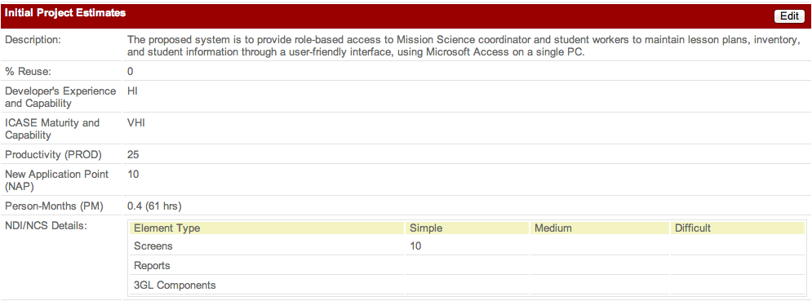
Figure 1: Initial project estimation for Mission Science Information and Database System

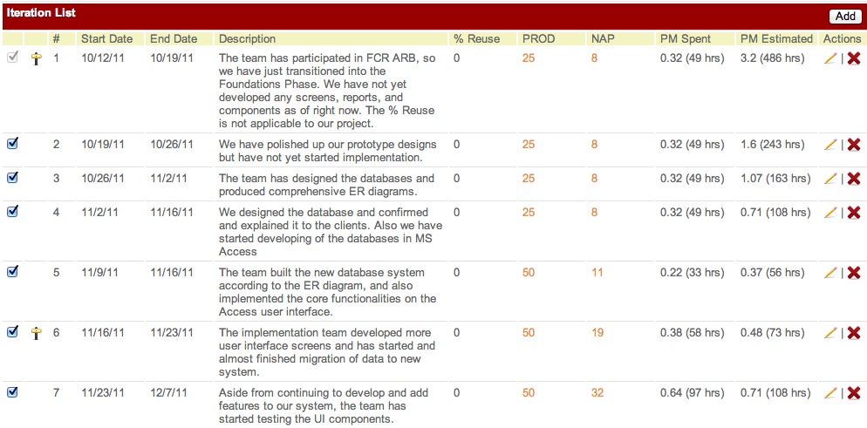
Figure 2: Cost estimation for Iterations 1-7
The project progress chart shows that our initial project estimate of 61 hours is drastically lower than the new estimate for iteration 7 of 108 hours. The accumulated effort currently reflects the amount of time spent on developing the user interface screens in Microsoft Access. More effort was spent in the most recent iterations because more features could be added once database system was built and finalized, whereas in the earlier development iterations, UI builder sometimes had to wait for database builders to finish building database.

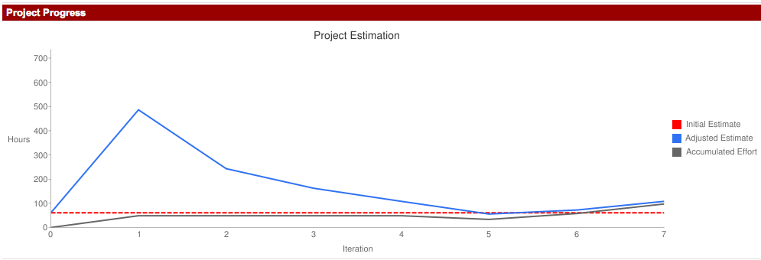
Figure 3: Project Progress Chart

